

Sennheiser TeamConnect Ceiling Microphones Now Integrate with Avonic CamDirector

Voice Tracker software utilises directional audio information from the Sennheiser TCC 2 or TCC M to enable superior video and audio for UC deployments

Barcelona, Spain – January 30, 2025 — Sennheiser, the first choice for advanced audio technology that makes collaboration and learning easier, announced that its award-winning TeamConnect Ceiling (TCC) microphones now work with Avonic CamDirector® Voice Tracker software. Installed in the Avonic CamDirector® AI Processing Unit, the voice tracker software utilises directional audio data from beamforming microphone arrays to pinpoint the location of sound sources and control the Avonic CM70 and CM90 cameras.

With this integration, the Sennheiser TCC 2 and TCC M microphones provide crystal-clear voice capture with 360° coverage, delivering voice data to the CamDirector® system for accurate speaker localisation. By isolating the speaker’s voice, the camera then transitions to the active speaker, enhancing the user experience in installations such as meeting rooms, lecture spaces, and live broadcast studios.

“We’re incredibly excited about the integration of these leading Sennheiser and Avonic solutions,” said Charlie Jones, Senior Partner Relations Manager, Business Communications, Sennheiser. “To match the sophistication of the TCC microphones, the company looks for partners that can work flawlessly with our robust products. The Avonic CamDirector software does exactly that. It’s akin to having a studio director onsite that can automatically manage camera angles and transition between shots — creating a seamless, captivating video feed with Trusted Sennheiser Audio Quality.”

The TCC M allows integrators the versatility to offer elevated meeting experiences across a range of flexible and hybrid meeting spaces and learning environments. With its adaptive, intelligent beamforming technology, the TCC M ensures Trusted Sennheiser Audio Quality every time. Seamless integration with single cable mode and numerous design and installation options ensure TCC M transforms any room into a hub of collaboration.
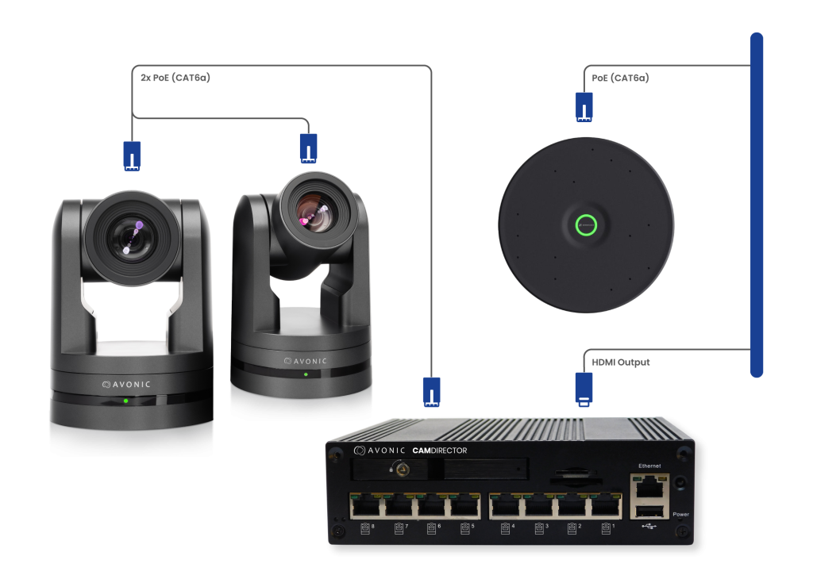
CamDirector® Voice Tracker with
Sennheiser TeamConnect Ceiling Medium microphone

With its functional square form factor, the TCC 2 gracefully integrates into the design of modern meeting rooms — simply by replacing a ceiling tile. The TCC 2 is a real problem solver that allows cable free tables and flexible furniture arrangements, while offering all the TCC Solutions benefits like Trusted Sennheiser Audio Quality, efficient setup, brand agnostic integration, simple management and control, sleek design, and a sustainable impact.

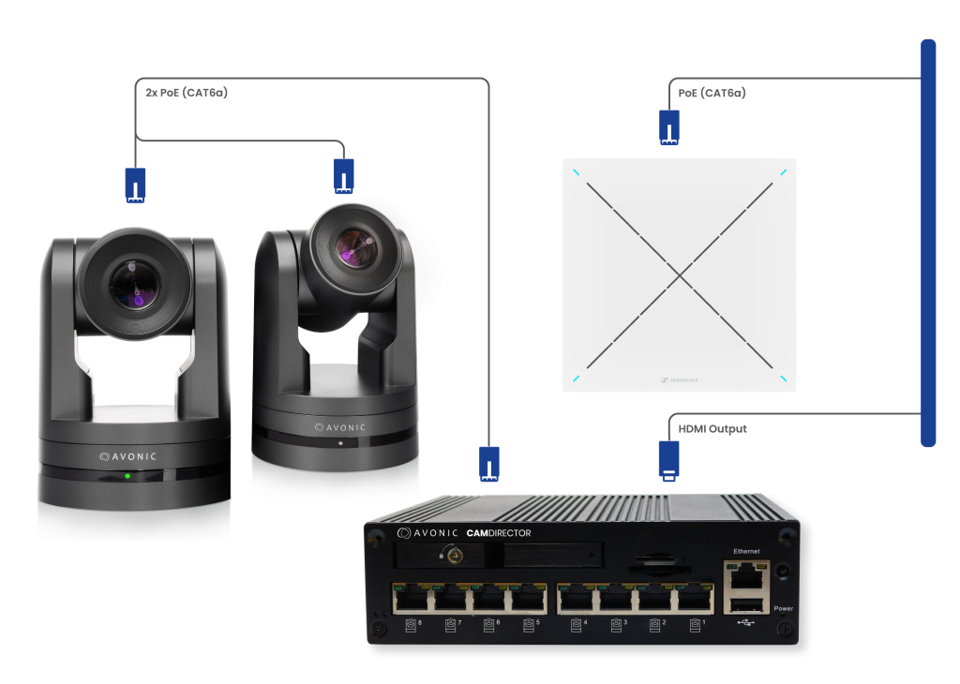
CamDirector® Voice Tracker with Sennheiser TeamConnect Ceiling 2 microphone

With Sennheiser’s superior audio input and CamDirector’s® AI-based tracking, the system ensures a fully automated AV setup. This integration is perfect for environments where hands-off control is essential, allowing teams to focus on content without technical distractions.
Avonic will be participating in Sennheiser’s ISE25 Hunt for the Perfect Pair campaign at Integrated Systems Europe (ISE) 2025 in Barcelona, Spain on February 4 - 7. ​ More information about Sennheiser’s partner and alliance activity at ISE can be found here.
###

About the Sennheiser brand
We live and breathe audio. We are driven by the passion to create audio solutions that make a difference. Building the future of audio and bringing remarkable sound experiences to our customers – this is what the Sennheiser brand has represented for more than 75 years. While professional audio solutions such as microphones, meeting solutions, streaming technologies and monitoring systems are part of the business of Sennheiser electronic GmbH & Co. KG, the business with consumer devices such as headphones, soundbars and speech-enhanced hearables is operated by Sonova Holding AG under the license of Sennheiser.

www.sennheiser.com
www.sennheiser-hearing.com

